**Requirements:**

* SQL Server Reporting Services (2005, 2008, 2008R2) native mode
* IIS 6 or later
  + APS.Net 4
  + Silverlight 4

**How to Install:**

1. Install it: prompts.msi
2. Verify Silverlight Application: <http://localhost:8080/prompts/>

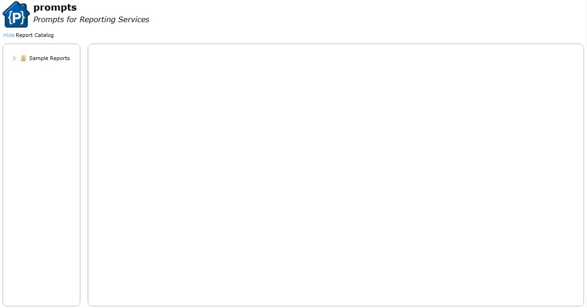

1. Create 2 folders on report server /Reports and /Prompt Reports

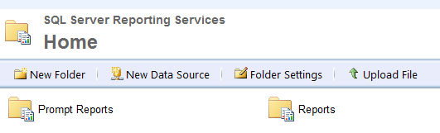

**Common Problems:**

* .Net 4 has not registered in IIS. Run c:\windows\[microsoft.net](http://microsoft.net)\framework64\v4.0.30319\aspnet_regiis /i
* Windows Authentication in IIS has not been enabled: 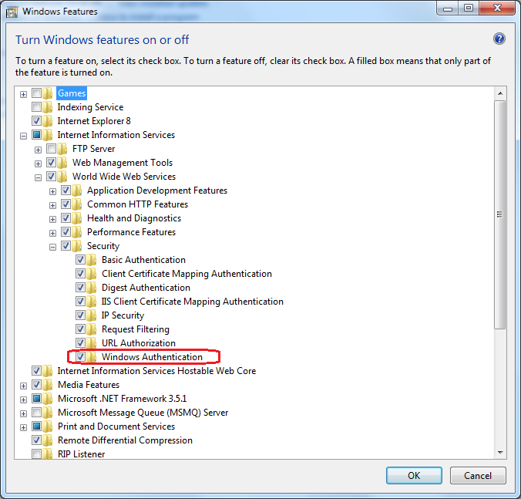
* Virtual directory Authentication:
  + The easiest configuration is only Windows Authentication enabled for Prompts, only Windows Authentication and ASP.NET impersonation enabled for Prompts.Service

